Hackathon Documentation

Problem Statement:

This dataset can be used to build machine learning models to predict diabetes in patients based on their medical history. This can be useful for healthcare professionals in identifying patients who may be at risk of developing diabetes and in developing personalized treatment plans.

* Created new Repo for Hackathon in Github

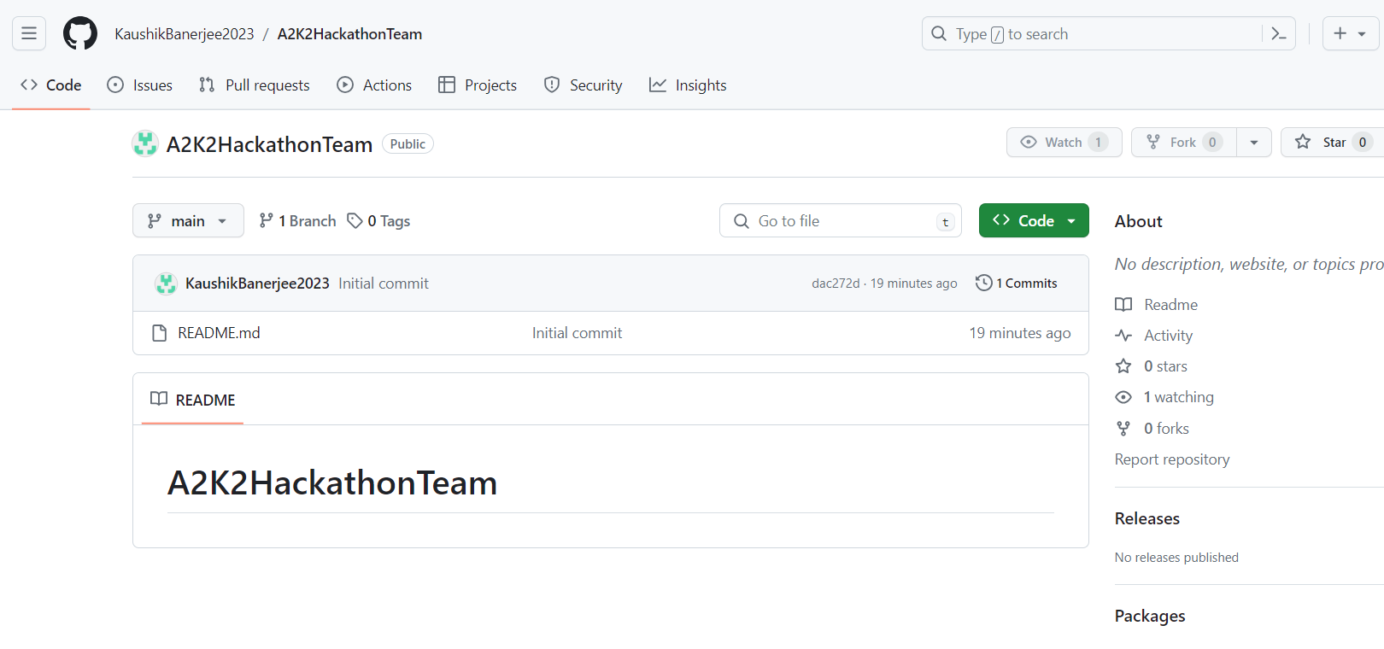

* Querying the source data diabetes.csv (Attached in Appendix)

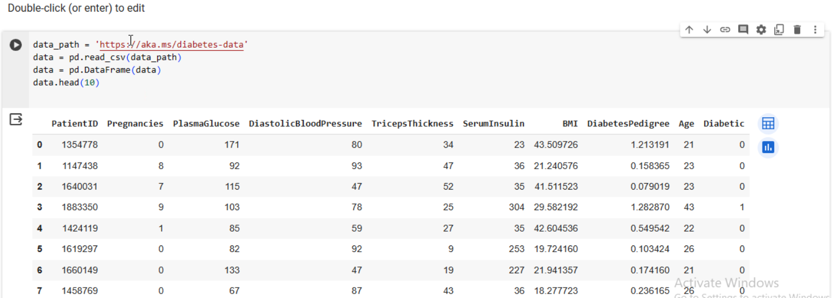

* Data Corrections 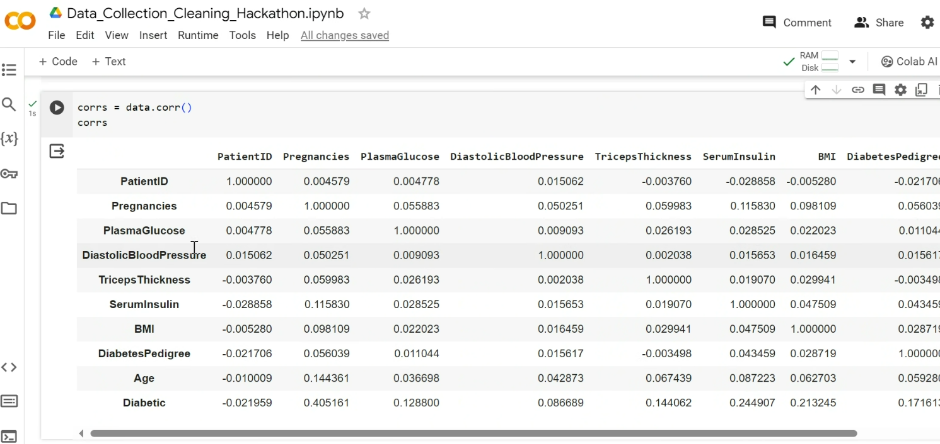
* Generating PIE chart based on Source Data

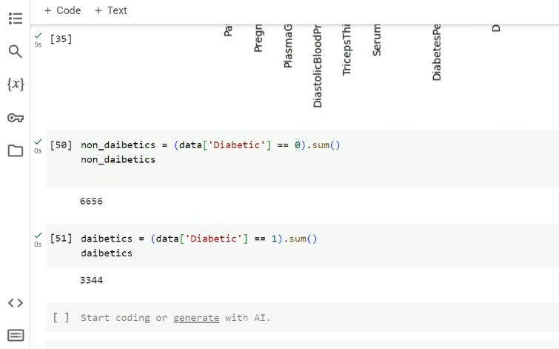

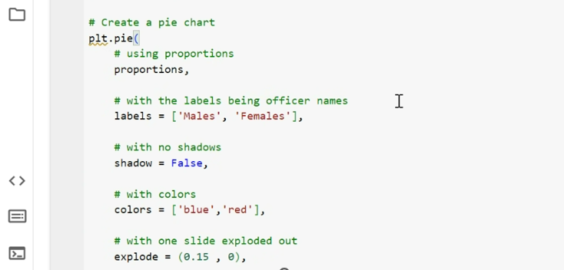

* Piechart

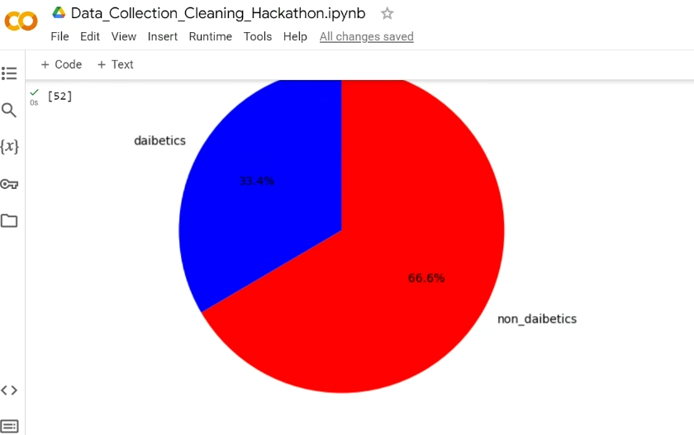

* Training the Model (Stage 1)

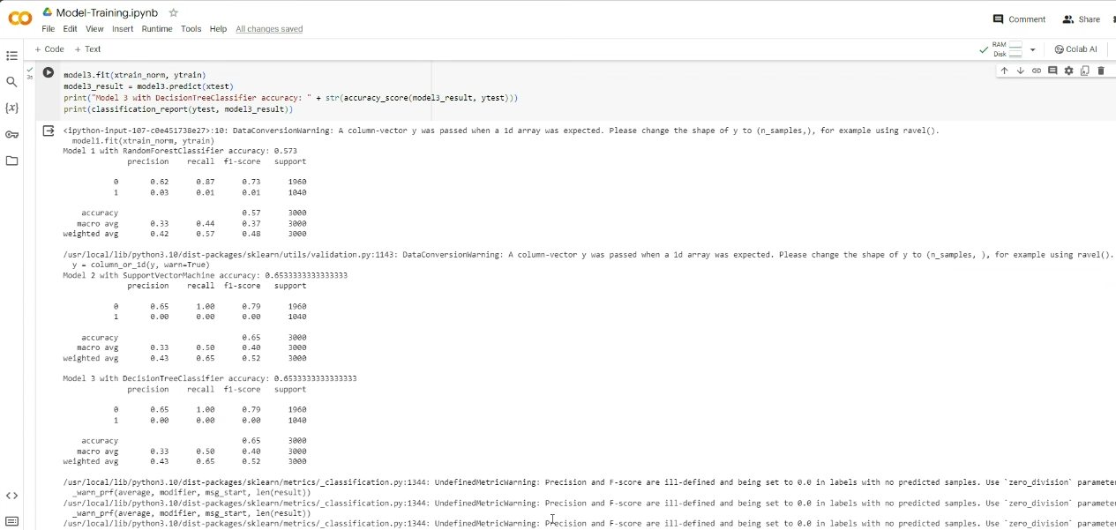

* Training the Model (Stage 2)

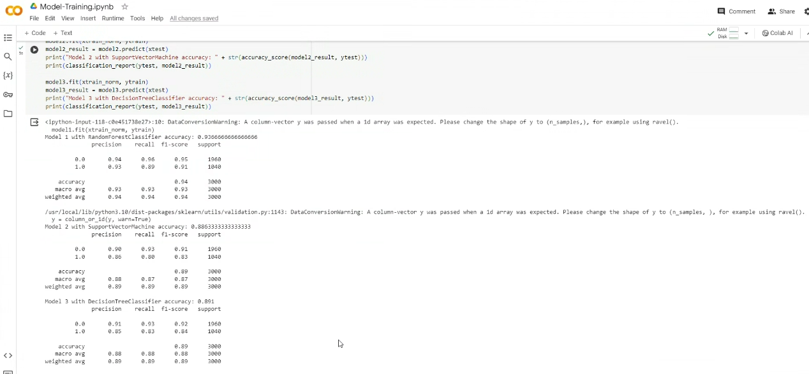

* Pipeline configuration setup:

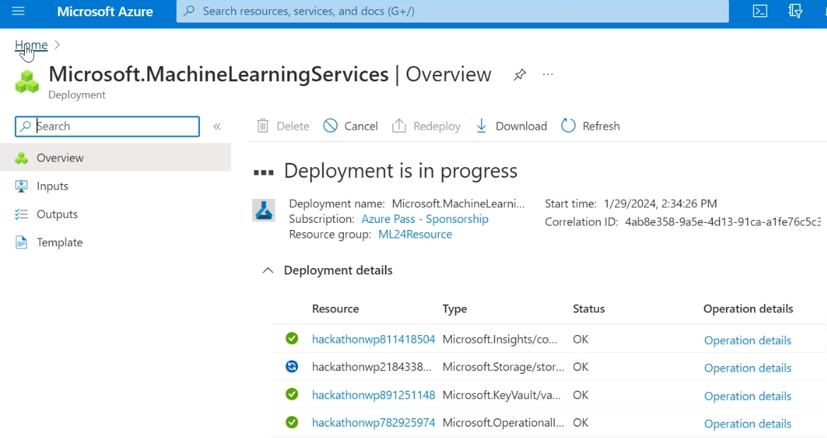

* Dataset Configuration Setup:

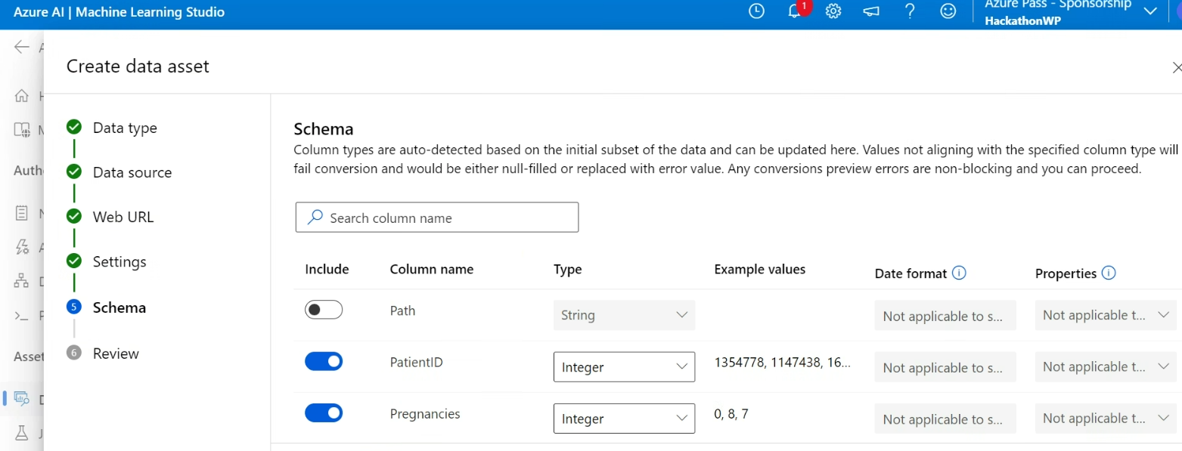

* Training configuration setup:

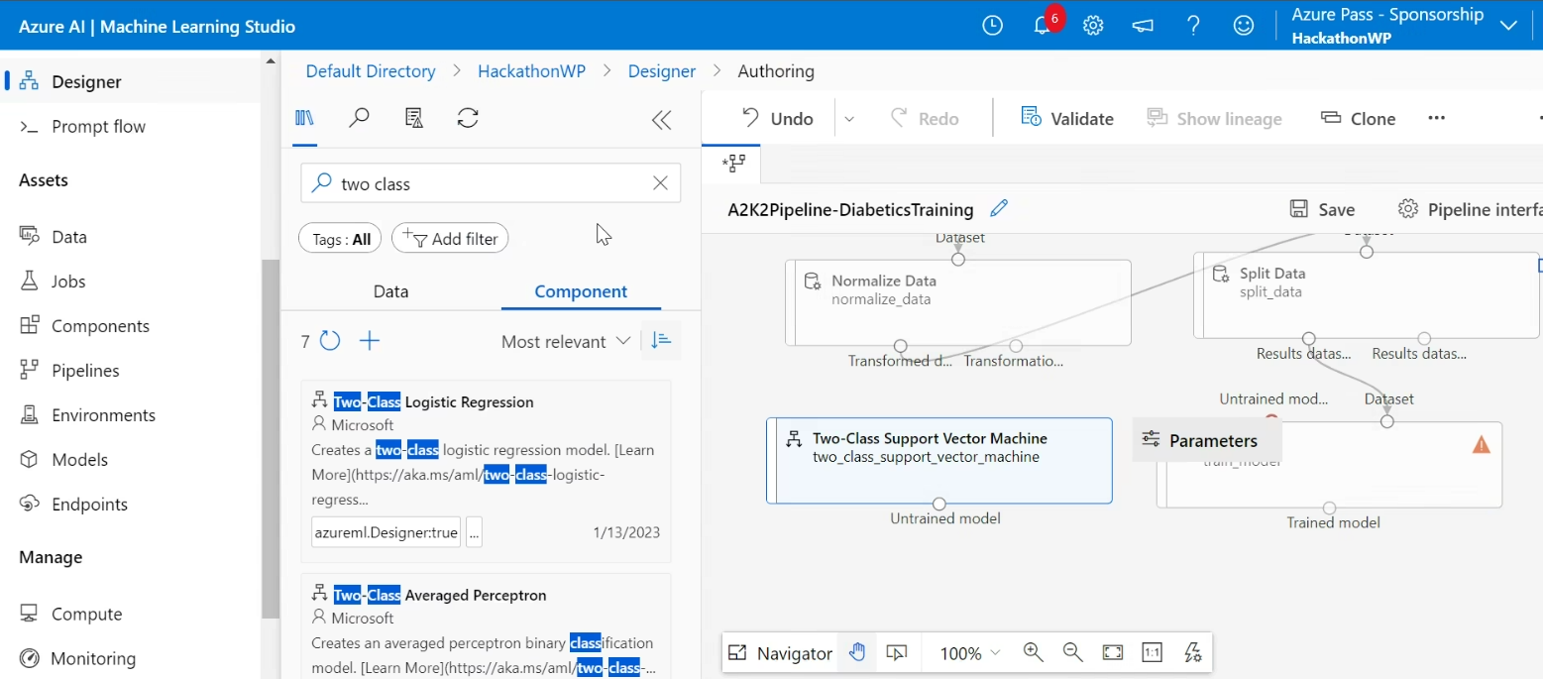

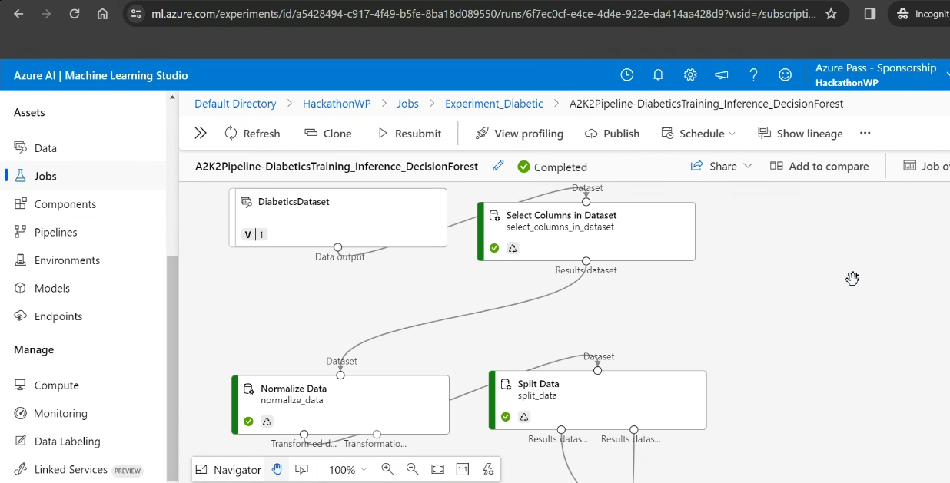

Result:



Open AI a Basic Chat Bot:

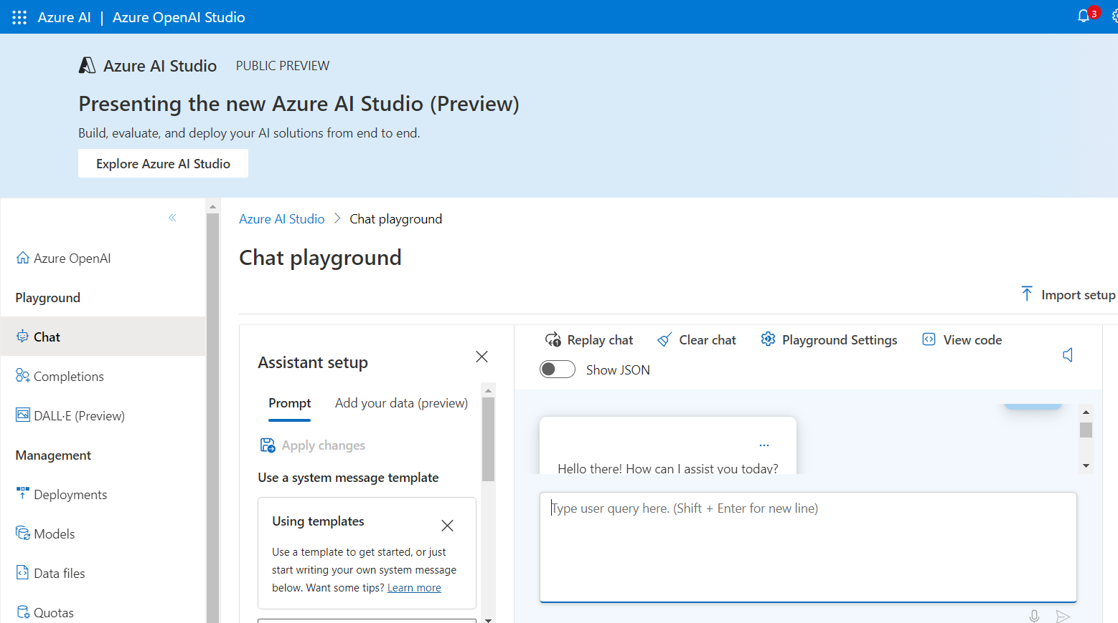

DALL-E Play ground

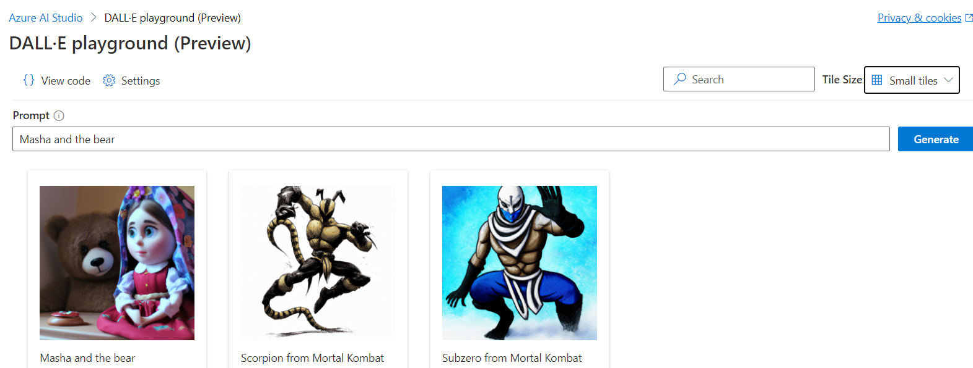

Appendix:

Source Data



Python File

